**Name:** Davy Nolan

**Performed:** Friday December 1st,

2017, 14:00 – 16:00 pm

**Date:** 5th December 2017

**Class:** Electrotechnology CS1025

***Laboratory Experiment 5***

**Introduction**

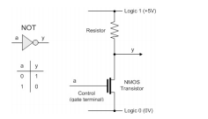In the first part to this experiment, a NOT gate was to be constructed using inverters. The inputs and outputs were to be viewed and the truth table was to be verified. An inverter is a component or device that inverts the state or logic level of a signal to the opposite logic level. NOT gates take in a logic input and then give out the opposite logic for the output. A transistor is a semiconductor device with 3 connections which is capable of amplification and rectification.

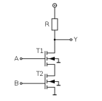In the second part of the experiment, a second transistor was added. The inputs and outputs were to be viewed and a truth table was to be determined.

**Equipment used:**

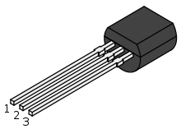2N7000 E-MOSFET Transistor: A transistor is a semiconductor device with 3 connections which is capable of amplification and rectification.

1 = Source

2 = Gate

3 = Drain

**Resistor:** limits and regulates the flow of current in a circuit.

**Part 1 explained:**

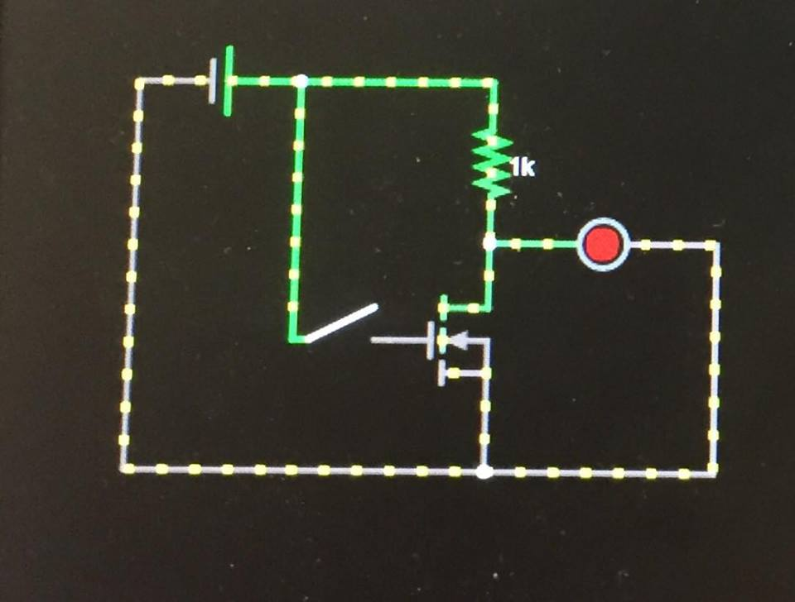The resistor is used in this circuit in order to protect the transistor, so it does not get damaged. The transistor takes the input and then inverts it, creating an opposite output.

**Results:**

|  |  |  |
| --- | --- | --- |
| ***Switch Status*** | ***LED Status*** | ***Voltage*** |
| Open | ON | 5 volts |
| Closed | OFF | 0 volts |

As you can see in the table above, when the switch in open, the LED turns on and when the switch in closed, the LED is off; therefore the inverter works and the NOT gate was successfully created. The truth table has been verified.

The transistor can only conduct current across from the drain to the source when the voltage that is fed into it is high. When the voltage entering the transistor is 5V, the transistor is able to function.

**Part 2 Explained:**

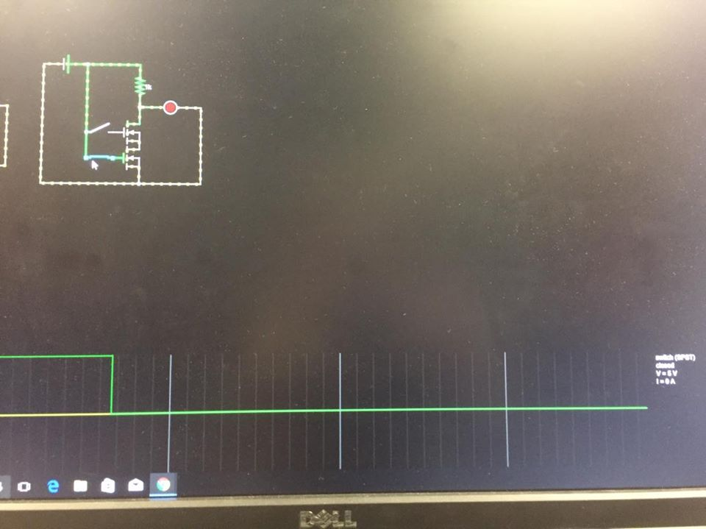In this part of the experiment, another switch and another transistor were added. This resulted in the creation of a NOR gate.

**Results:  
*NOR gate truth table***

|  |  |  |
| --- | --- | --- |
| *Input A* | *Input B* | *Output* |
| 0 | 0 | 1 |
| 0 | 1 | 0 |
| 1 | 0 | 0 |
| 1 | 1 | 0 |

|  |  |  |
| --- | --- | --- |
| *Switch A* | *Switch B* | *LED status* |
| Open | Open | ON |
| Open | Closed | OFF |
| Closed | Open | OFF |
| Closed | Closed | OFF |

As seen in the results above, the NOR gate was successfully created. The only case in which the LED turns on is when both switches are open. The LED is off for all other cases.

**Conclusion:**If the input voltage is high, then the transistor is able to function and if the input voltage in low then the transistor turns off. The point of this experiment was to create a NOT gate in the first part and a NOR gate in the second part and to see how they function.